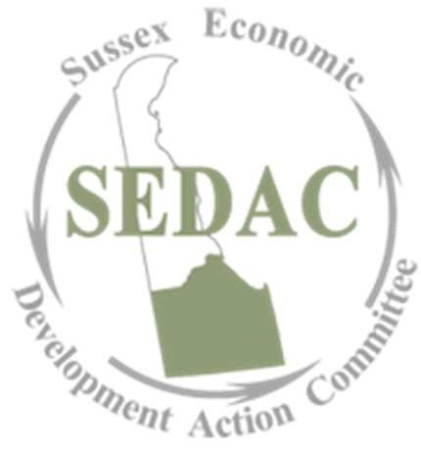
www.sedac-de.org
Annual Report
2020
SEDAC Mission Statement:
To leverage the experience, intellect, and creativity of the Sussex County community to inform, develop, recommend, and communicate strategies for creating sustainable economic prosperity.
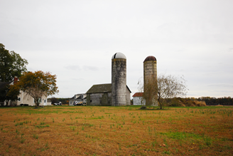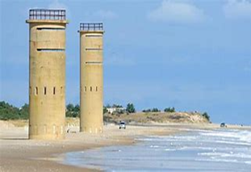
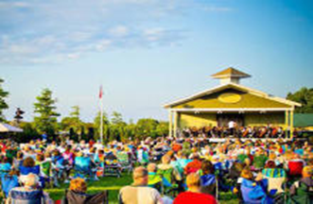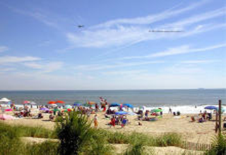

Report from the Chair
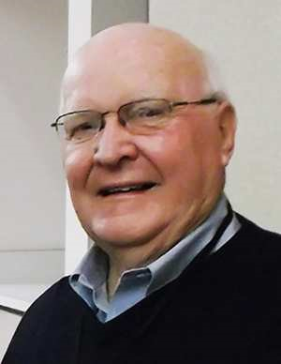

The year 2020 was anything but perfect. As a nation, state and county, I think that I can speak for all of us that this is a year that will not soon be forgotten. It has become the year of where were you when all this happened? SEDAC was affected just as all organizations. Our last in person meeting was in February, but like many of you, I have learned much more about ZOOM than I ever wanted to know. But, given all the problems associated with the pandemic, SEDAC still managed to have a good year. Membership continues to grow and expand in the type and size of businesses who have joined with us, sharing our view of a more sustainable economic prosperity for all of Sussex. We will continue to push for jobs that will keep our young people here, protect our existing businesses and industries, and make Sussex County even more attractive to new business. Feel free to contact any member (listed in this report) or contact me at jconaway@hotmail.com or visit our website www.sedac-de.org

We continue to distribute editorials concerning economic development in Sussex County and we will continue to do so in 2021. Having said that, however, we have found a couple of local newspapers have been reluctant to publish these editorials or hold them so long that the time-sensitive comments lose their effectiveness We hope that this was only a breakdown in the newspaper’s procedures and not an attempt at censorship on their part. In 2020, these editorials included our 2019 annual report, a report on a Growth Fund that would help pay for growth, reassessment, worker’s compensation, efforts to expand broadband in Sussex County that helped get the lion’s share of a $20 million dollar state grant for Sussex County, some random thoughts in a pandemic-challenged world, compliments to the County Council for planning ahead with their Fiscal 2021 budget, kudos to the Sussex County Planning and Zoning Commission for continuing to do business as best they could during the pandemic and, finally, some positive economic development happenings that are going on now in our County.

We met with two of the nine Chambers of Commerce in Sussex to discuss common interests. At the same time, we began discussions with the Public Private Partnership (PPP) to have that group pay more attention to Sussex County. We had hoped that this small beginning would lead to greater cooperation among the Economic Development players in Sussex. Unfortunately, the pandemic has put a damper on this. However, we are not faint of heart and we will reopen these discussions when conditions improve. We will continue our sponsorship of the Sussex County Today and Tomorrow Conference.

We have created a committee to work with the medical community to address the shortage of doctors in Sussex. Under the leadership of David Baker, we have begun the process of trying to help with this major problem. We have already offered one suggestion that would go a long way in addressing this issue. The State of Delaware since 1970, has funded a program (DIMER) that has assisted Delaware Students in getting into Sydney Kimmel Medical College and the Philadelphia College of Osteopathy. It also helps pay their expenses. But here is the problem. These students are not required to practice in Delaware upon graduation. Since 1970, there have been a total of 1,206 DIMER students. Of that total only 229 have returned to Delaware. That’s 19% and, of that total group, only 37 have returned to Sussex. That is only 3%. A simple addition of a requirement to come back to Delaware for a period of time would dramatically help solve this problem. We asked the Sussex delegation to the General Assembly to sponsor such legislation but, so far, no response. How bad is the shortage? In 2011 there were 163 primary care physicians in Sussex County. In 2018 there were only 112. Now we are faced with a new problem – the concierge doctor. Under these physicians, you pay a sum of money up front and, in return, you are guaranteed service. More on this to come.

SEDAC also submitted to the Sussex County Council our suggestions as to how to implement the section of the Sussex County Comprehensive Plan that deals with Economic Development. These suggestions included 1) a fully staffed and functional Economic Development Office; 2) a review of the County regulations that hinder growth; 3) strengthening partnerships with and among the various economic development groups in the County; 4) established a Sussex County Business Resource Center; 5) develop additional job-training partnerships with the education community; 6) continue to promote the agricultural industry and, finally; 7) to support continued growth of tourism.

Over the past year we have endorsed a number of projects and government policies. These included the Apprentice Program in Delaware, changes to the State’s Worker’s Compensation Insurance Program, and we continued our support for the “Ready In Six” program that could dramatically reduce regulatory delay for economic development projects, affordable housing, endorsed additional funding for Primeros Pasos that would help them in their efforts to increase the size of their Georgetown facility, supported the County’s program to accelerate funding to improve the roads in Sussex (F.A.S.T.), supported the Freeman Foundation in its “Our Town” application through the National Education Association and reluctantly, said goodbye and thank you to Steve Guthrie for his great efforts as Superintendent of the Sussex Vocational School District.

I would be very remiss if I didn’t thank member and Secretary, Linda Price for all of her efforts on behalf of SEDAC, from scheduling our monthly meetings, preparing our annual report and keeping our minutes precise and to the point. Without all of her efforts, I am not sure just where SEDAC would be. Thank you, Linda!

I want to take this opportunity to thank our membership for their efforts to make SEDAC successful. We are all volunteers, and, without their help and advice, nothing would be possible. We wish all of you a Happy New Year and look forward to the day that our children will not have long drives home during the holidays because the good paying jobs that they hold elsewhere are right here in Sussex County, Delaware

Joe Conaway
Chairperson
Sussex Economic Development Action Committee

SEDAC Board Members

2020

2020 Executive Committee Directors
Joe Conaway, Chairperson Bob Ruggio
Walt Bryan, Vice Chairperson Lillian Harrison
Kevin Yingling, Treasurer Rich Hartnett
Linda Price, Secretary

Board Members
Joe Conaway Doug Liberman
Linda Price Chris Baker
Kevin Yingling Rob Tunnell
David Root Ray Sander
Scott Thomas Cathy Bassett
Ernie Felici Brian McGlinchey
Bob Ruggio Sheldon Hudson/Jamie Burke
Chris Weeks Dave Speicher
Ed Lewandowski Brian Shannon
Pete Keenan Steve Weick
Walt Bryan Lillian Harrison
Dean Holden Trisha Newcomer
Jerry Esposito Mike Vanderslice
Charlie Timmons Bobbi Barends
Bobby Horsey Bob Wheatley
Casey Kenton Sandra Ware
Dona Troyer David Baker
Patricia Anderson Pat Ryan
Mark Davidson Steve Henschel

Ex-Officio Members
Sussex County Association of Towns (SCAT)
Bill Pfaff, Sussex County Economic Development
Lauren Swain – Delaware Division of Small Business
Jim Provo - SBA
SEDAC’S Continued Strategic Doing

- SEDAC continues monthly to address Strategic Doing Initiatives as identified from our 2017 workshop
- 2020 efforts were made on the following strategic doing initiatives
  - Support job creation and retention
  - Every job is worthy and thoughtful of consideration
  - Focus on communicating the role of SEDAC
  - Strengthen the relationships between partners
  - Make connections/always aware – 2020 saw an increase in identifying the right connections and making them a part of the SEDAC board. As word and visibility widens, SEDAC continues to add strategic partners
  - Understand partners – Economic Development focus (i.e. Kent County Partnership/Delaware Prosperity
  - Promote SEDAC
  - Workforce Development & Affordable housing – continuing to hold workshops between the local High Schools and businesses – focus on trades and workforce development
- How do we get there o Op Eds o Social Media o Direct Action o Endorse Economic Development Projects o Monthly agenda discussions
- 4 Op Eds were completed by Chairman, Joe Conaway and circulated through local print media
- o Annual Report o Vocational Education o New Directions
  - Affordable Housing and Industrial Parks
- Social Media initiatives – LinkedIn page saw increased traffic due to consistent posting relative to all things business throughout the County.

SEDAC Reaches Across and Beyond the County

In order to support our mission of economic development in Sussex County, our members participate with a number of local and regional initiatives that help develop businesses, entrepreneurs, and the region overall.

Sussex County Council
SEDAC regularly updates Sussex County Council on our progress. We meet with Council members when economic development issues arise. SEDAC is committed to keeping County Council up to date on our progress and success stories. SEDAC continues to stay involved in happenings within the County and 2020 saw a better partnership develop

Sussex County Conference
2020 saw the cancellation of many events, notwithstanding the Sussex County Today and Tomorrow Conference. An event that is looked forward to by many in Sussex County, it was sad to see, but we all look forward to a bigger and better conference in 2021.

Organizations that have presented to SEDAC

SEDAC recognizes the importance of keeping up to date on major activities in Sussex
County and the surrounding region. These guest speakers have made presentations to SEDAC in 2020……

- Town of Laurel – The Ramble
- Laurel Redevelopment Corporation
- Orsted Wind Farm
- Ray Bevins – Delaware Division of Parks & Recreation
- Town of Millsboro
- Trinidad Navarro – Delaware Insurance Commissioner
- Joe Schell – Sandhill Fields
- Delaware Secretary of Information James Collins
- Dwayne Kilgo – IT Manager/Sussex County
- Dr Kenneth Sunnergren
- Patti Grimes – Freeman Stage
- Peter Ettinger – BIO Energy

